USECASE:

A use case is a methodology used in system analysis to identify, clarify and organize system requirements. The use case is made up of a set of possible sequences of interactions between systems and users in a particular environment and related to a particular goal. The method creates a document that describes all the steps taken by a user to complete an activity.

ACTOR:

User: Represents individuals who use the WhatsApp application.

USECASE DIAGRAM:

Use case diagrams are usually referred to as behavior diagrams used to describe a set of actions (use cases) that some system or systems (subject) should or can perform in collaboration with one or more external users of the system (actors).

Register Account: The process of creating a new WhatsApp account.

Send Message: Allows a user to send a text message to another user or a group.

Send Media: Allows a user to send media files (images, videos, audio, documents) to another user or a group.

Create Group: Enables a user to create a new group and add other users to it.

Join Group: Allows a user to join an existing WhatsApp group if invited.

Block User: Lets a user block another user to stop receiving messages from them.

Unfriend/Leave Group: Allows a user to unfriend another user or leave a group.

Set Profile Picture: Enables a user to set or change their profile picture.

Set Status: Allows a user to set or update their status message.

Voice/Video Call: Allows a user to initiate a voice or video call with another user or a group.

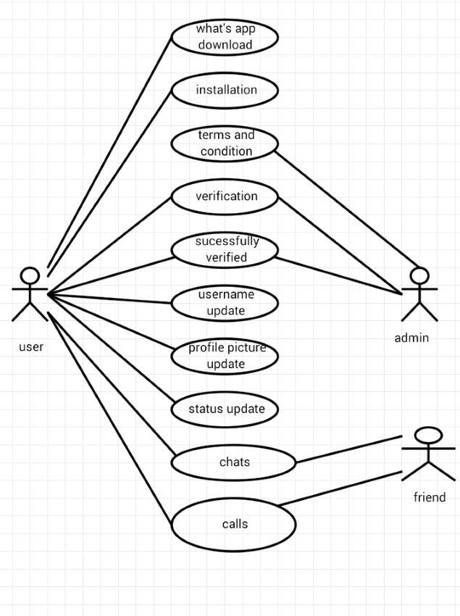

USECASE FOR WHATSAPP:

| USECASE | ACTOR | DESCRIPTION |
| --- | --- | --- |
| LOGIN | ACTOR | Login  Enter the Mobile number  Enter to Mobile number to generate OTP |
| WHATSAPP DETAILS | ADMIN | Edit account  Delete account  View actor account details |
| ACCOUNT DETAIL | ADMIN,ACTOR | Add account  Delete account  View chat and status  View history of an account |

SCENARIO:

| S.NO | ACTION | SOFTWARE REACTION |
| --- | --- | --- |
| 1. | Actor connecting to corresponding account through ATM card | System request the following data is from   * ACCOUNT * ATM CARD * MOBILE NUMBER |
| 2. | Actor Giving input by entering the pin code | The ATM machine verify that the above 3 items have been filled out  If any data is missing the machine warns the actor and the scenario continues with #1  If all data has been entered, the Machine asks the actor to verify the their transaction  If the customer indicates they would like to cancel the scenario ends here.  If the Actor indicates that their transaction is not correct, the scenario continues with #1 |
| 3. | Actor confirms that their transaction is correct | If the Actor says their transaction is incorrect,the scenario returns to #2  If the Actor confirms their transaction,the Machine ask the Actor To proceed further by asking to enter the choice cash withdrawal,saving or balance enquiry. |